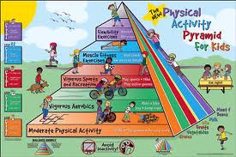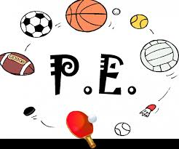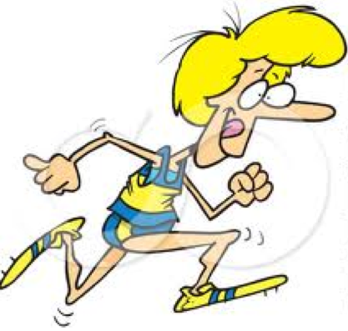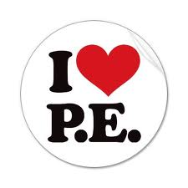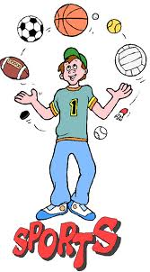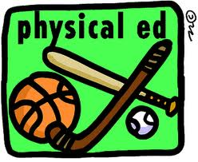

Students will have the opportunity to have P.E. twice a week and every other Friday. Students are encouraged to have tennis shoes and comfortable clothes that they can move and be active in on these days. My belief is that as long as students are positive, giving their best effort and courteous to others, their PE experience will be a positive and rewarding journey.

##### Mrs. Alison Feeney

##### Elementary PE

##### Centura Public Schools

#### Physical Activity Rocks!

###### Feel free to contact me:

308-485-4258 ext. 149

Alison.feeney@esu10.org

## Students will be using the Fitness Gram for their testing this year!

We will test out three times during the 2013-2014 school year. Here are the tests that your student will be measured on:

-Aerobic Capacity

(pacer test)

-Body Composition

(height/weight)

-Muscular Strength, Endurance and Flexibility

(sit ups, trunk lift, push ups)

**RESPONSIBLE:**

-make sure that you are on time to class each day

-make sure that you are wearing tennis shoes each class

-make sure that you return equipment properly once instructed

- make sure that you are dressed in proper active wear.

**RESOURCEFUL**:

-make sure that you are helpful to the teacher, and classmates

-make sure that you give your best effort with each activity and unit that you participate in

**RESPECTFUL**:

-make sure that you treat your classmates with kindness

- make sure that you treat the equipment and the things in the gym with care

- make sure that you treat the teacher with kindness

8:20-10:00 6th Grade Reading

10:00-10:30 6th Grade PE

10:15-11:15 Plan

11:15-11:45 Interventions

12:30-1:00 2nd Grade PE

1:00-1:30 3rd Grade PE

1:30-2:00 4th Grade PE

2:00-2:30 Kindergarten PE

2:30-3:00 1st Grade PE

3:00-3:30 5th Grade PE

### Mrs. Feeney’s Schedule

**K-12 Nebraska Physical Education Essential Learnings**

**THEME: Physical Education Literacy**

**Strand 1:** Skills

**Strand 2:** Knowledge

**THEME: Physical Activity and Fitness**

**Strand 3:** Active Lifestyle

**Strand 4:** Fitness

**THEME: Physical Activity Behavior**

**Strand 5:** Responsible Behavior

**Strand 6:** Awareness

**Strand 1: SKILLS**

Demonstrates competency in motor skills and movement patterns needed to perform a variety of physical activities.

**Strand 2: KNOWLEDGE**

Demonstrates understanding of movement concepts, principles, strategies and tactics as they apply to the learning and performance of physical activities.

**Strand 3: ACTIVE LIFESTYLE**

Participates regularly in physical activity.

**Strand 4: FITNESS**

Achieves and maintains a health-enhancing level of physical fitness.

**Strand 5: RESPONSIBLE BEHAVIOR**

Exhibits responsible personal and social behavior that respects self and others in physical activity settings.

**Strand 6: AWARENESS**

Values physical activities for health, enjoyment, challenge, self-expression, and social interaction.

###### Every child is a winner when they try their very best!

# 3 R’S OF PE-